Official entry form for DRIVERS
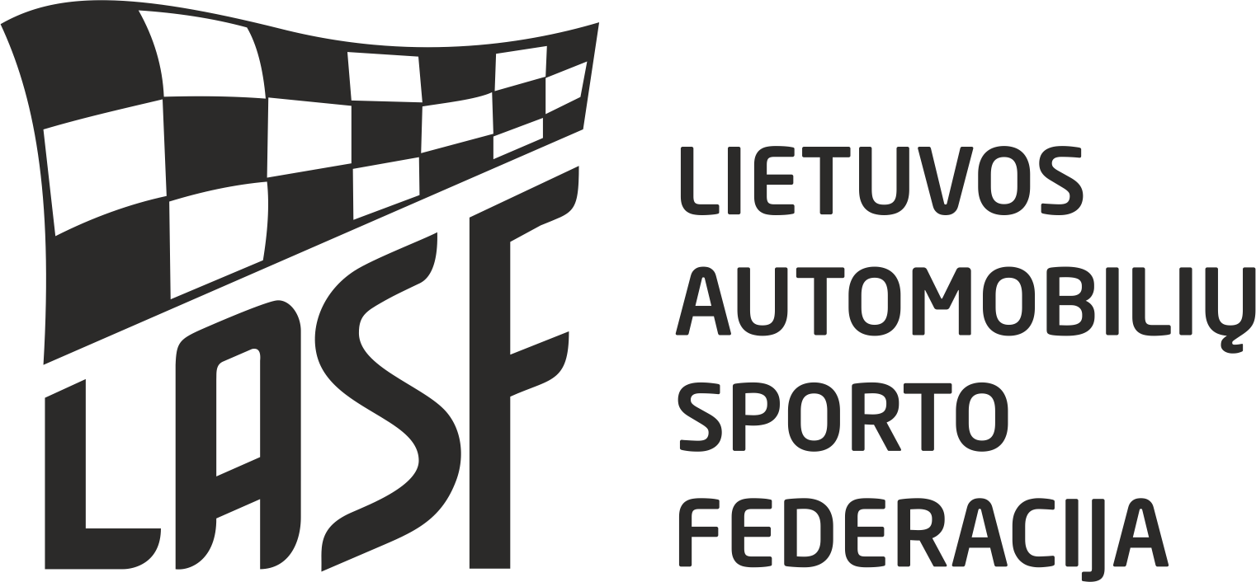

2017 LITHUANIAN RALLYCROSS CHAMPIONSHIP

stage 3
Date of event: 07-08.10.2017 place: Słomczyn Country: Poland
ORGANIZER  Automobilklub Rzemieślnik  46 Żytnia street  01-198 Warszawa, Poland  tel. +48 22 632 81 49  www.rallycross.pl  OPONEO Motorsport  7 Łucka street  85-185 Bydgoszcz, Poland  tel. +48 604 112 025  E-Mail: biuro@rallycross.com.pl Website:www.rallycross.com.pl |  | DIVISIONS  DIVISION FOR LT RX (X)  START NR. _____
  SuperCars
  Super1600
  TouringCars
ENTRANT  Name:  Country:  Address:  Licence Nr:  Tel:  Fax: E-mail:  Signature: |  | DRIVER  Name:  Country:  Address:  Licence Nr:  Date of birth:  Tel:  Fax:  E-mail:  Signature:
ENTRY FEE:  Lithuanian rallycross championship  Entry fee – 150 EUR. |  | Mark: Model:  Mark of engine:  Capacity of engine (cm3):  Min weight according regulations (Kg):  Real weight (Kg): Power(HP):  Technical passport No:

We confirm that we have read and understood the provisions of the International Sporting Code, the Rallycross Technical Regulations and the Rallycross Sporting Regulations and we agree, on our own behalf and on behalf of everyone associated with our participation in the NEZ Championships for Rallycross drivers, to observe and be bound by them (as supplemented or amended). We declare that we have examined this Entry Form and that the information given is true, correct and complete. We understand that any change to the details given on this Entry Form must be notified to the organiser.

