Baltic Touring Car and LT Racing Championship Technical Regulations 2015

1. Definitions
FIA – International federation of automobiles.
ASN – National federation of automobile sport.
BRC – Baltic Race Car.
BRC1: cars built on basis of serial production GT or Touring car, manufactured after 1970, with engine capacity 1800-2800cm³.
BRC2: cars built on basis of serial production GT or Touring cars and manufactured after 1970, with engine capacity 2801-5000cm³;
GT3 and GT4 cars with valid or expired FIA homologation.
BRC3: cars built on basis of serial production GT or Touring car, but not complying to BR1, BR2 regulations;
GT1, GT2 cars with valid or expired FIA homologation;
Tubular frame and monocoque + tubular frame based cars, self-made and so-called low-cost kit cars, no passed trough the crash test and without crash box by FIA rules and without ASN or FIA homologation;
Tubular frame and monocoque + tubular frame based cars, self-made and so-called low-cost kit cars, no passed trough the crash test and without crash box by FIA rules and with national ASN homologation;
Serial production cars with aluminum body frame.
1.1. Special requirements for BRC3 cars
These cars according their type must comply FIA safety prescriptions.
The driver in his normal driving position must be located on one side of the longitudinal center-line of the car.
Maximum engine capacity for tubular frame and monocoque + tubular frame based cars, self-made and so-called low-cost kit cars, no passed trough the crash test and without crash box by FIA rules and without ASN or FIA homologation - 3000 cm³ (included the coefficients of turbo or compressor).
Requirements for open type cars. The car must have two foot wells, defined as two free symmetrical volumes on either side of the longitudinal center-line of the car, each one having a minimum vertical cross-section of 750 cm2. This cross-section must be maintained from the pedal faces to the vertical projection of the center of the steering wheel. The minimum width of each foot well is 250 mm and this width must be maintained over a height of at least 250 mm.
The openings which correspond to the driver and passenger seats must enable the horizontal template defined in Drawing 259-2 in FIA Appendix J to be placed vertically within the cockpit, with the steering wheel removed. It must be possible to lower the template to a point 150 mm below the lowest point of the cockpit opening.
Organizer has right to impose additional requirements for these cars (reduce fuel tank capacity, install air restrictors, add extra weight).

Drivers willing to take part in competition with BRC3 car, before every event must full fill the form with their car data according the tables 3.3. and 3.4. of these regulations. This form must be given to technical commission, before the event.

1.2. Notes
When FIA homologated car or car from international mono-series have some point of not accordance with these rules, this question will be resolved by the event organizer or Series Board.
All quoted points (articles) in these rules are from FIA Appendix J.

2. The quotients for BRC1, BRC2 supercharged engines
2.1. Diesel engines with turbo - 1,4;
2.2. Otto engine with turbo - 1,7;
2.3. Bi-turbo (including Diesel engines) - 2,2;
2.4. Compressor with mechanical gear - 1,4.

3. Weights
3.1. Weighting procedure - car with all lubricants, with minimum 3 liters of the fuel (in fuel tank) and driver with his full equipment.
3.2. Minimum weight of the cars according to engine capacity:
BRC1: 1800…2000 cm³ - 1100kg;
2001...2800 cm³ - 1150kg;
BRC2: 2801...3199 cm³ - 1190kg;
3200…3500 cm³ - 1225kg;
3501…5000 cm³ - 1265kg.
GT3 and GT4 cars - weight according to homologation.
BRC3: GT1 and GT2 cars – weight according to homologation.
Other cars - weight calculation according to quotient tables 3.3. and 3.4.
 | 3.3. Table - quotients of theoretical engine capacity for BRC3 cars
 |  | A | 2 valves per. cylinder, 2/4 stroke engine | 1,00
 |  | B | More than 2 valves per. cylinder 2/4 stroke engine, diesel engines | 1.25
 |  | C | 2valves per. cylinder and Supercharged 2/4 stroke | 2.00
 |  | D | Radial Wankel | 2.00
 |  | E | More than 2 valves per. cylinder and Supercharged 2/4 stroke | 2.00
 |  | F | Radial Wankel and Supercharged | 2.60
 |  | G | FWD (calculated subsequently factor) | 0.95
 |  | H | 4WD (calculated subsequently factor) | 1.10
 |  | I | ABS brakes (calculated subsequently factor) | 1.10
 |  | J | Sequential gearbox / dogbox (calculated subsequently factor) | 1.10

3.4. Table - quotients of weight for BRC3 cars

T |  | P
Touring cars |  | Experimental cars: tubular frame and monocoque + tubular frame based cars, self-made and so-called low-cost kit cars without ASN or FIA homologation, no passed trough the crash test and without crash box by FIA rules and serial production cars with aluminum body frame.
Coefficient | Weight KG | Coefficient | Weight KG
0-2200 | 820 | 0-3000 | 700
2201-2400 | 840 | 3001-3500 | 750
2401-2600 | 860 | 3501-4000 | 800
2601-2800 | 880 | 4001-4500 | 850
2801-3000 | 900 | 4501-5000 | 900
3001-3200 | 920 | 5001-5500 | 950
3201-3400 | 940 | 5501-6000 | 1000
3401-3600 | 960 | 6001-6500 | 1050
3601-3800 | 980 | 6501-7000 | 1100
3801-4000 | 1000 | 7001-7500 | 1150
4001-4200 | 1020 | 7501-8000 | 1200
4201-4400 | 1040 | 8001-8500 | 1250
4401-4600 | 1060 | 7501-8000 | 1200
4601-4800 | 1080 | 8001-8500 | 1250
4801-500 | 1100
5001-5200 | 1120
5201-5400 | 1140
5401-5600 | 1160
5601-5800 | 1180
5801-6000 | 1200
6001-6200 | 1220
6201-6400 | 1240
6401-6600 | 1260

3.5. Examples how to calculate weight for BRC3 cars.
3.5.1. Touring car with engine capacity 3246cc:
3246cc x 1,25 (More than 2 valves per cylinder 2/4 stroke engine) x 1,10 (Sequential gearbox / dogbox) = 4463. It means that car weight with driver according coefficient table “T“ is 1060kg.
3.5.2. Experimental cars with engine capacity 1998cc:
1998cc x 1,25 (More than 2 valves per. cylinder 2/4 stroke engine) x 1,10 (4WD system ) = 2747. It means that car weight with driver according coefficient table “P“ is 700 kg.

4. Engine
4.1. For BRC1 and BRC2 cars it is allowed to use any serially produced engine of the same manufacturer (as bodywork) or manufacturer concern.
Examples:
- in BMW 3 ser. it is allowed to use BMW 5 ser. engine;
- in SKODA or SEAT it is allowed to use VW or AUDI engine.
4.2. For BRC3 cars - engine is free.
Example:
- in TOYOTA it is allowed to use HONDA engine.
4.3. Motorcycle engines are forbidden in all cars.
4.4. Only serial production cylinder blocks and cylinder heads of the same make (manufacturer) should be used.
4.5. The engine must be located in the original engine compartment.
4.6. If the car has a lubrication system which includes an open type sump breather, this must vent into a catch tank of at least 2 liters capacity.
4.7. The intake system is free.
4.8. The exhaust system is free, but must be located by FIA Art. 252.3.6. It is recommended to use catalytic element in exhaust system.
4.9. The noise level for all classes is limited to 110dBA/ 3500 rpm (by FIA method; microphone 50cm/ 45 degrees at outlet of exhaust pipe) or by specially regulations in each competition site.
4.10. Engine cooling system is free. Installation according FIA Art. 253
4.11. Engine fuel feed system is free. Installation according FIA Art. 253±
4.12. Engine ignition and electrical system including ECU is free.
4.13. Otherwise engine parts and systems are free.
4.14. When measuring engine capacity difference of ±2% accepted.

5. Fuel
5.1. The choice of fuel is free.
5.2. If using bioethanol E85, the car should be marked with stickers “E85” on both sides of the car, not higher than 200 mm above rear wheel arch.

5.3. Sticker for bioethanol users

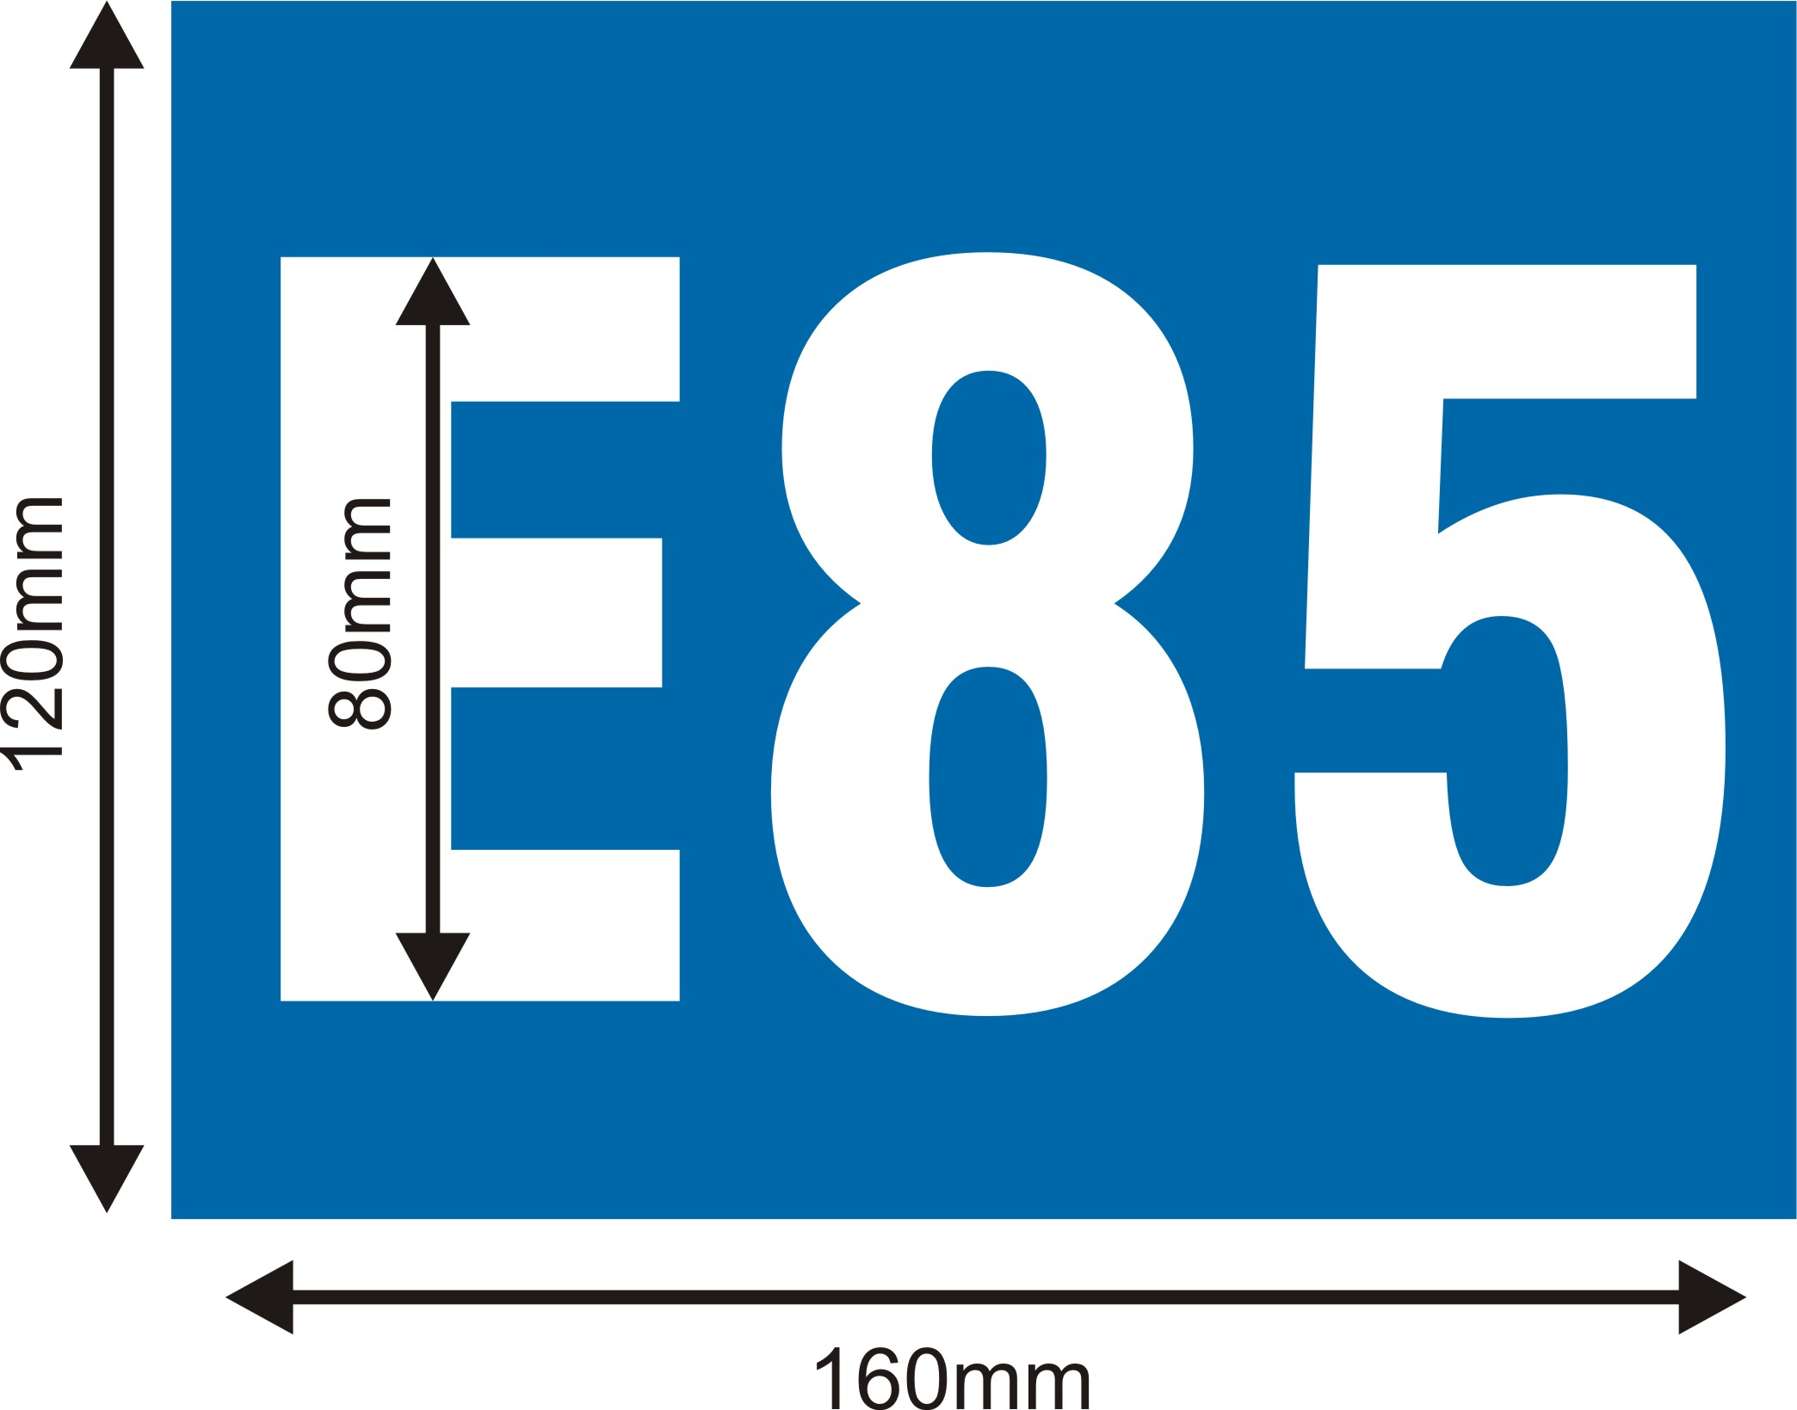

6. Transmission
6.1. Four-wheel drive is allowed, but only in cars, produced with such type of transmission in serial version of the model.
6.2. Reverse gear in working order is compulsory.
6.3. It is allowed to make necessary body changes in order to make room for the transmission. Safety and proper fastening have to be assured.
6.4. Otherwise the transmission is free.

7. Brakes
7.1. Brake system should consist of two separate circuits, operated by the same pedal. The system must be designed so that, if leakage or failure occurs in one circuit, the pedal shall still operate the brakes on at least two wheels.
7.2. The brake fluid tanks may be fixed inside the cockpit, on condition that they are securely fastened and protected with liquid and flame-proof covering.
7.3. Brake line installation according FIA Art. 252.10. and 253.4.
7.4. Brake light switch should be in proper working order.
7.5. It is permitted to use any type of brake balance adjusters and handbrake.
7.6. Otherwise the brake system is free.

8. Wheels
8.1. Magnesium wheel rims are prohibited.
8.2. The choice of tires is free.
8.3. Tire pre-heating with devices powered by electricity or any type of fuel (gas) is prohibited.

9. Steering
9.1. Four-wheel steering is prohibited.
9.2. Steering wheel lock should be dismantled.
9.3. Otherwise the steering is free.

10. Suspension
10.1. Active suspension systems (systems enabling the flexibility of springs, shock absorbers, roll-bars and the ground clearance height of the car to be controlled while the car is in motion) are prohibited.
10.2. Suspension parts made partially or completely from composite materials are prohibited.
10.3. Otherwise suspension is free.

11. Bodywork
11.1. General for cars BRC1 and BRC2:
Only passenger car bodyworks are permitted. Appearance of the cars must be proper.
Visible traces of rust must be removed and the car body repaired without weakening of the supporting structures and changing of the body design.
Lateral profile of the car body at the bonnet, windshield, roof, rear window, and boot lid must keep its original appearance after removal of spoilers.
11.2. Decorative body parts, protectors, name plates, etc. may be removed.
11.3. Supporting structures - propeller shaft tunnel, side panels, door pillars, roof, car floor and a/b/c-pillar - may not be made lighter.
11.4. Modification of the car floor between the rear edges of the front wheels and the front edges of the rear wheels is allowed only for modification of the transmission, suspension or exhaust muffler, and the floor may not become weaker as a result of such modifications.
11.5. Reinforcement of car bodywork is allowed.
11.6. Covering of the floor is allowed.
11.7. Use of aerodynamic elements under the floor and outside the car is permitted with conditions:
- must be made with highest safety standards, and safely attached;
- should not touch the ground, when both tires on one side of the car are flat, with the exception of side curtains made of soft and flexible material;
- should not protrude more than 30 mm from the side of wheel rim (picture 11.7.1.), when looking from the front and the rear. This measure will be taken from the rims of the widest axle.

11.7.1. Picture

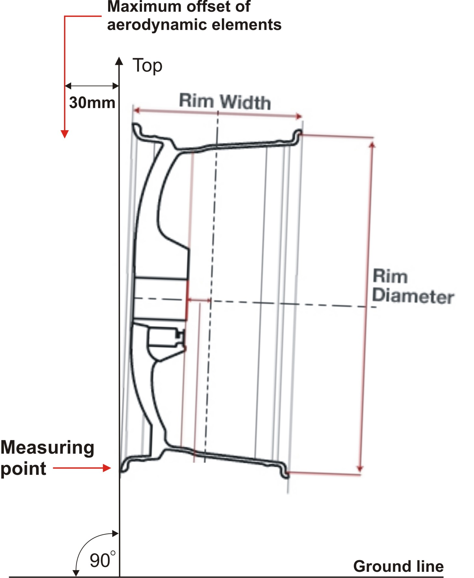

- front splitter should not protrude more than 200 mm from the bodywork (looking from the top);
- rear wing (spoiler) and diffuser should not protrude more than 300 mm from the bodywork (looking from the top);
- rear wing (spoiler) should not be higher than 150 mm from the roof line for hatchback and caravan bodywork types (looking from the side);
- rear wing (spoiler) should not be higher than the roof line for sedan bodywork type (looking from the side).
11.8. Roof panel, bonnet and boot covers, wings can be made of composite materials.
11.9. All doors can be made of composite materials.
11.9.1. The drivers door must be upholstered. The upholstery may be original or replaced with metal sheet (minimum thickness 0,5 mm) or with carbon panel (minimum thickness 1 mm) or with another fireproof material with minimum thickness of 2 mm.
11.9.2. It is recommended to fill drivers door inner space with energy absorbing material.

11.9.3. Side protection panel (the minimum configuration of this panel must comply with a drawing 255-14 FIA Art. 255), made from non-inflammable composite materials must be installed if:
- drivers door is made of composite materials;
- drivers door side protection bar is removed.
11.9.4. All doors must remain safely closed during the race (mechanical fixation).
11.9.5. Must be possible to open and close driver and passenger doors from inside and outside.
Outside door opening handles must be clearly visible or indicated.
11.10. Stationary doors (so-called NASCAR-doors). Minimum dimensions of the window opening in these doors should exceed 400mm in height and 800mm in length.
The driver should be able to exit car independently with full equipment in maximum 7 seconds trough drivers side and in maximum 9 seconds through passenger side.
11.11. Windows.
11.11.1. The windscreen must be of original shape and consist of triplex glass or may be in polycarbonate on condition that thickness is not less than 6mm and external surface is treated to resist wear. In order to protect the windscreen, the addition of maximum of 4 translucent films on its external face is permitted.
11.11.2. The rest of the windows may be replaced by transparent polycarbonate (minimum
thickness 3 mm) or other transparent material (minimum thickness 2 mm) that does
not brake when folded.
11.11.3. It is compulsory to use clear protection films on all original glass windows (except windscreen).
11.11.4. Tinting or (and) covering windows with non-transparent materials is prohibited, with the exception of the upper edge of the windscreen (maximum height: 150 mm).
11.12. Wipers. If the car has a windscreen, it must be fitted with at least one wiper which is in working order throughout the event.
11.13. Mirrors. All cars should be equipped with inside rear view mirror (except cars without windscreen) and external rear view mirrors (minimum surface 90 cm2) on both sides. Mirrors can not be folded during race or qualification.
11.14. Cockpit.
11.14.1. All mats, upholstery (except that of the driver’s door), passenger seats and their fastening elements may be removed from the cockpit.
11.14.2. All unnecessary components fastened by bolts and nuts may also be removed from the cockpit.
11.14.3. Dangerous sharp edges or projecting elements are not allowed in the cockpit.
11.14.4. Cockpits of all closed cars must be fitted with a fresh air inlet and used air outlet. The inlet cannot be connected with engine or fuel tank compartment.

11.15. Towing device. All cars should be equipped with towing devices at the front and rear of the car. It must be clearly visible and painted in yellow, red, orange or another color that contrasts from the car bodywork color. The hole in towing device must allow the passage of a cylinder with a minimum diameter of 60 mm and maximum diameter of 100mm. It must be capable of supporting a minimum traction force of 3000 N.

12. Lights
All cars must be equipped with:
- one pair of low beam headlights (55W, if using LED-s the luminous intensity has to be of same magnitude);
- one pair of red taillights (10W, if using LED-s the luminous intensity has to be of same magnitude);
- one pair of red brake lights (21W, if using LED-s the luminous intensity has to be of same magnitude.

13. Electrical system
13.1. Electrical system is free, but must be installed with a circuit breaker to disconnect battery from all electrical equipment by FIA Art. 253.13. The driver, when seated normally with his safety belts fastened, must be able to shut the switch inside of car.
13.2. The battery must be securely fixed (FIA Art. 255.5.8.3). The “dry” battery must be completely electricaly protected and “wet” battery must be completely protected inside a box made of insulating material.

14. Telemetry
The use of “one way” telemetry is free. This means that the transmission of data and/ or signals from the car to an external installation is permitted. The transmission of data and/ or signals from an external installation to the car is NOT permitted.

15. Safety prescriptions
15.1. Lines, pumps and filters by FIA Art. 253.3.1. and 253.3.2.
15.2. Additional fasteners by FIA Art. 253.5.
15.3. Safety belts by FIA Art. 253.6.
15.4. Driver seat by FIA Art. 253.16.
The franchise:
- it is allowed using of seats in compliance with 8855/1999 FIA standard also 2 (two) years after valid date without authorization by the manufacturer.
- it is allowed fixing of seat supports for anchorage points with welding to body shell.
15.5. Extinguisher systems. By FIA Art. 253.7. Additional use of manual extinguishers recommended.

15.6. Fuel tanks original or racing fuel cells by FIA Art.253.14.
The franchise:
- it is allowed use also fuel tanks by SFI standard 28.1 and 32.1
- it is allowed use also fuel tanks 2 (two) years after valid date without authorization by the manufacturer.
15.7. The drivers door net by FIA Art. 253.11.
15.8. Safety cage by FIA Art. 253.8.
Minimum structure as follows: Specified drawings numbers are given according to FIA Appendix J Art 253.8 . (www.fia.com).
A. Basic structure: according to FIA Art. 253. 8.3.1 (drawings 253-1, 253-2, 253-3)
B. Diagonal stabilizers: at least 2 diagonal stabilizers are obligatory (drawing 253-4 and 253-5 together or 253-7). Settings according to 253.8.3.2.1.1 directions.
C. Side protection structure: ”X” shaped on both sides (drawing 253-9). Settings according to 8.3.2.1.2 directions. If the car already has side protection structures that are set according to drawings 253-10 or 253-11, then these are not necessary to change to be suitable to 253-9.
D. Roof reinforcement: according to c 8.3.2.1.3 directions (drawings 253-12; 253-13 or 253-14). One diagonal version according to drawing 253-12 is also allowed if its first part is fixed on the driver side.
Where the drivers crash helmet could come into contact with safety cage, must be the
protective padding, complying with the FIA 8857-2001 standard, type A (see technical list no. 23 „Roll Cage Padding homologated by the FIA“). The padding must be secured, so that it does not spin around the bar.

16. Drivers equipment
Drivers are responsible for using only valid FIA homologated equipment (for international events) and other safety means. It is compulsory to use FIA homologated head and neck equipment FHR (HANS / Hybrid).

Prepared by :
Egidijus Janavicius
Mindaugas Bogusevicius

Confirmed by EASU, LAF and LASF Circuit Racing Committee
10.11.2014

