Tulkotāja piezīmes:
- latviešu tekstā apakšpunkts 4.1. atkārtojās divas reizes, tāpēc numerācija tika koriģēta;
- pārbaudi 5.5.jēgu oriģinālā un tulkojumā; pieturzīmju lietojums oriģinālā neļauj viennozīmīgi saprast jēgu;
- 13.1.1. – ģeneratoru drīkst noņemt?

Technical Regulations

for National class

in Road Racing on Circuits.
1 General
1.1. These Regulations are issued by LAF (Automobile Federation of Latvia), and they are in force as of January 1, 2008, till December 31, 2009.
1.2. Vehicles in their entirety shall comply with these Regulations throughout the competition.
1.3. Any measurements shall be done on flat horizontal surface.
1.4. All participants of the event shall have in their possession Technical Passports of their vehicles issued by the National Automobile Federations recognised by FIA. The Technical Passport shall be immediately presented upon the request of the officials of the event.
2 Definitions of certain terms
FREE – a part or a detail may be modified in any way or replaced; no restrictions concerning material, shape or number of these parts or details. This part or detail may be removed, if the removing does not contradict with the safety regulations.
To those parts or activities not referred to as „not restricted” the terms „original” or „not allowed” apply.
ORIGINAL – a part or a detail as installed by the vehicle manufacturer at the time of production of the vehicle without any mechanical, chemical, thermal or any other processing.
3 Vehicles
The vehicles allowed to participate in events are the cars having the homologation in Group A Touring Cars, having four or five seats, and of which at least 2500 identical units have been manufactured in 12 consecutive months, and which comply with the Technical Regulations for the National Class or equal to them - „VW Golf 1600”. It is allowed to interchange parts and details of different models of the same vehicle make.
4 Safety measures
4.1. Protective net – compulsory. The net shall be attached to the safety cage above the driver window using fast detachment system; the net shall be detachable by one hand
4.2. Safety belts – minimum 5-point – complying with Art. 253, point 6, of Appendix J of International Sporting Code (ISC)
4.3. A driver must be able to unfasten the safety belt and leave a vehicle within 5 seconds.
4.4. Seat of the pilot – the original pilot’s seat must be replaced by the FIA homologated bucket seat (standard 8855/1999) with 5 (five) openings for the belts of safety harness. The seat may be in use for 5 years after the date of manufacture indicated thereon in accordance with FIA standard 8855-1999. The manufacturer can extend this period for 2 more years, and that shall be indicated on the seat according to FIA standard 8855-1999.
The seat shall be mounted with at least 4 (four) M8 bolts of 10.9. quality.
The seat shall be mounted in accordance with Article 253, point 16, of Appendix J of ISC.
It is allowed to participate in the event with the fibre-frame seats homologation of which has terminated not longer than three years before the date of the event. In each case it is decided by the Scrutineers of the event.
4.5. Safety cage – the vehicle shall have the safety cage in accordance with Article 253, point 8, of Appendix J to the ISC. The protective padding shall comply with Article 253, point 8.3.5, of Appendix J to the ISC.
4.6. Firefighting equipment - compulsory. Minimum mass of the powder - 4 kg. Fastenings and markings – in accordance with Article 253, point 7, of Appendix J to the ISC.
4.7. Outer garment, balaclava hood, shoes, gloves shall comply with FIA Standard 8856 – 2000. Undergarment - strongly recommended.
4.8. Helmet – according to FIA Technical List No. 25.
5 Bodywork
5.1. Bodywork - „original”. It is forbidden to reduce mass (by detaching metal – drilling, cutting etc.) of the load-bearing parts except in the places which are related to the installation of the safety cage and other systems. If bodywork with a hatch is used, the opening shall be closed by welding of steel sheet which is not thinner than material of the roof, maximum distance between welding points not exceeding 30 mm.
It is allowed to reinforce bodywork between the centres of the vertical axis of upper mounting points of front and rear shock-absorbers (+15 cm in both directions).
5.2. Front wings – „original”. Arches may be treated.
5.3. Doors, part of the bodywork –„original”. It is forbidden to use donors of another material. Handles and locks of the side-doors shall be in working order and keep the donors in closed position. The lock of the rear hatch (door) shall be removed during the race, or secured against locking by other means; the rear hatch (door) shall be equipped with at least 2 additional (easily accessible and openable from outside) fastenings precluding opening of it during the race. Inner side of the doors on the driver side shall have a cover of continuous metal (minimum thickness l mm) or of composite materials (minimum thickness 3 mm); it shall cover the doors fully below the window opening. The cover shall be safely fixed following the perimeter to all respective surfaces (maximum distance between rivets in one row – 80 mm). The window glazing on the pilot’s side shall be dubbed with the net in accordance with Article 253, point 11, of Appendix J to the ISC.
5.4. Bonnet – „original”. The bonnet shall be equipped with at least 2 additional fastenings precluding opening of it during the race. Original lock of the bonnet shall be removed during the race, or secured against locking by other means. No aerodynamic device is allowed on the bonnet.
5.5. It is allowed to remove from the bodywork any soundproofing and anticorrosion materials, carpets, trim etc.
It is not allowed to remove the original front trim of the cockpit.
It is allowed to remove original bumpers and replace them by other aerodynamic devices (spoilers) at the same time keeping the original front impact-absorbing design of the given model together with the mounting devices. The aerodynamic devices (spoilers) shall remain within the perimeter of the original model looking horizontally from the front and vertically from above.
5.6. Any aerodynamic devices shall be securely fastened, and they may not constitute any danger to the participants or spectators of the event. They may not be adjustable during the race. Security of the fastenings shall be determined by the Scrutineers of the event.
5.7. Glazing – the windscreen shall be multiple-layer (of Triplex type). Other glazing materials of the bodywork shall correspond to the original; they shall be equipped with the safety film on the inside. They may be originally tinted, but any additional tinting of the windows is prohibited. The windscreen wiper shall be operational at least on the pilot’s side.
5.8. Rear-view mirrors – there shall be one having minimum reflecting surface of 90 cm² on each side of the vehicle. Rear-view mirror in the cockpit is compulsory. The reflecting surface of the mirrors may not be damaged in any way.
5.9. Outer lighting devices – original compulsory. It is allowed to disconnect reversing light and fog lights.
The lights may be neither damaged in any way, nor tinted. At least 60% of the surface of the front lights shall be covered with a safety film. Rear lights in their entirety shall be covered with a transparent safety film. Minimum bulb output: 10 w – for position lamps, 21 w – for brake lamps. Lamps of positions lights and brake lights shall be separate.
5.10. Direction indicators – not restricted.
5.11. Devices for towing a vehicle – in accordance with Article 253, point 10.5, of Appendix J to the ISC.
6 Mass of the vehicle
6.1. Minimum mass of the vehicle at any moment during the race is 1100 kg for rear-wheel drive, and 1070 kg for front-wheel drive, together with a pilot having all equipment on and all technical fluids.
6.2. It is allowed to increase a mass of the vehicle with one or more ballasts provided that those are rigid homogenous blocks attached using the instruments and sealable, placed on the floor of the cabin or boot, visible and sealed by the Scrutineers.
The ballasts shall be attached to the bodywork/chassis using M8 bolts of quality 10.9 and counterplates in accordance with the figure 631.
Minimum contact area of bodywork/chassis and counterplate is 40 cm² in each point of attachment.
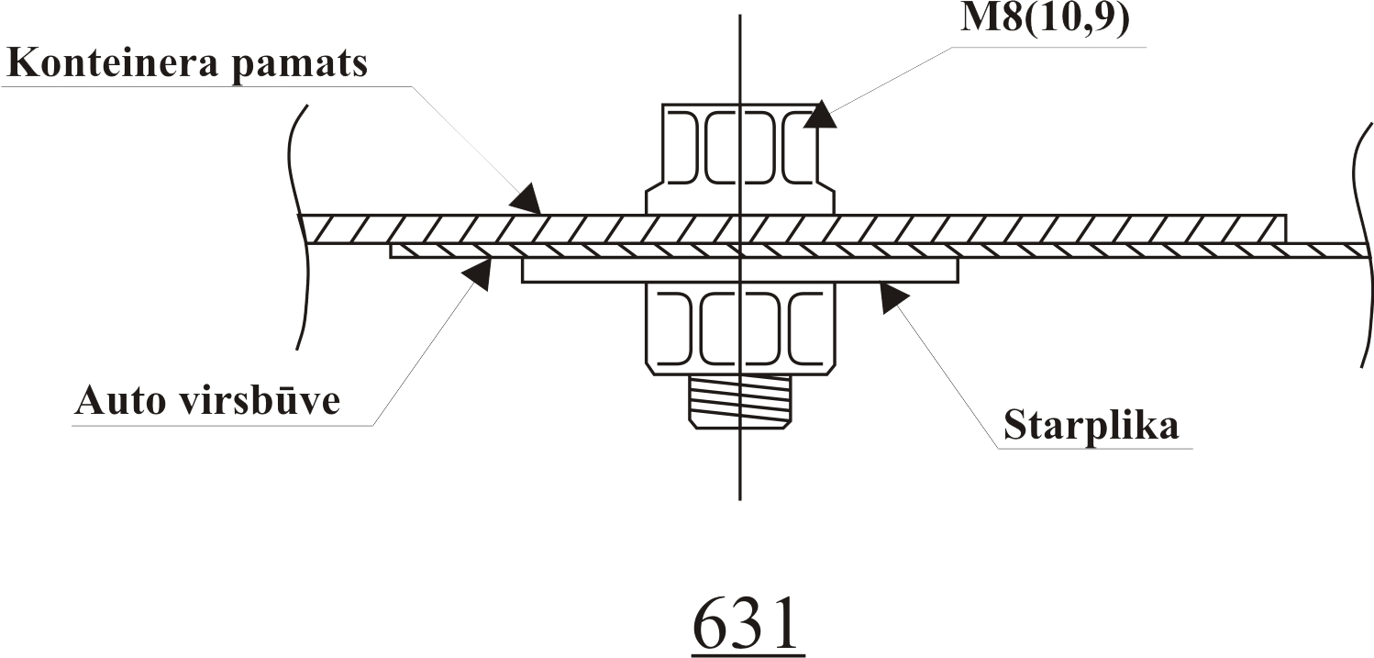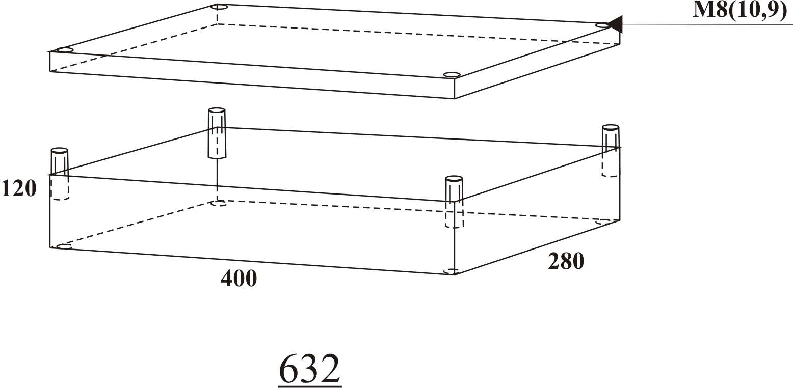

6.3. For any vehicle there shall be a possibility to attach additional weight container using four bolts in accordance with the figure 631. Thickness of the sheets of the container is 2 mm; other dimensions are shown in figure 632. Placement of the container in the vehicle is given in figure 633.

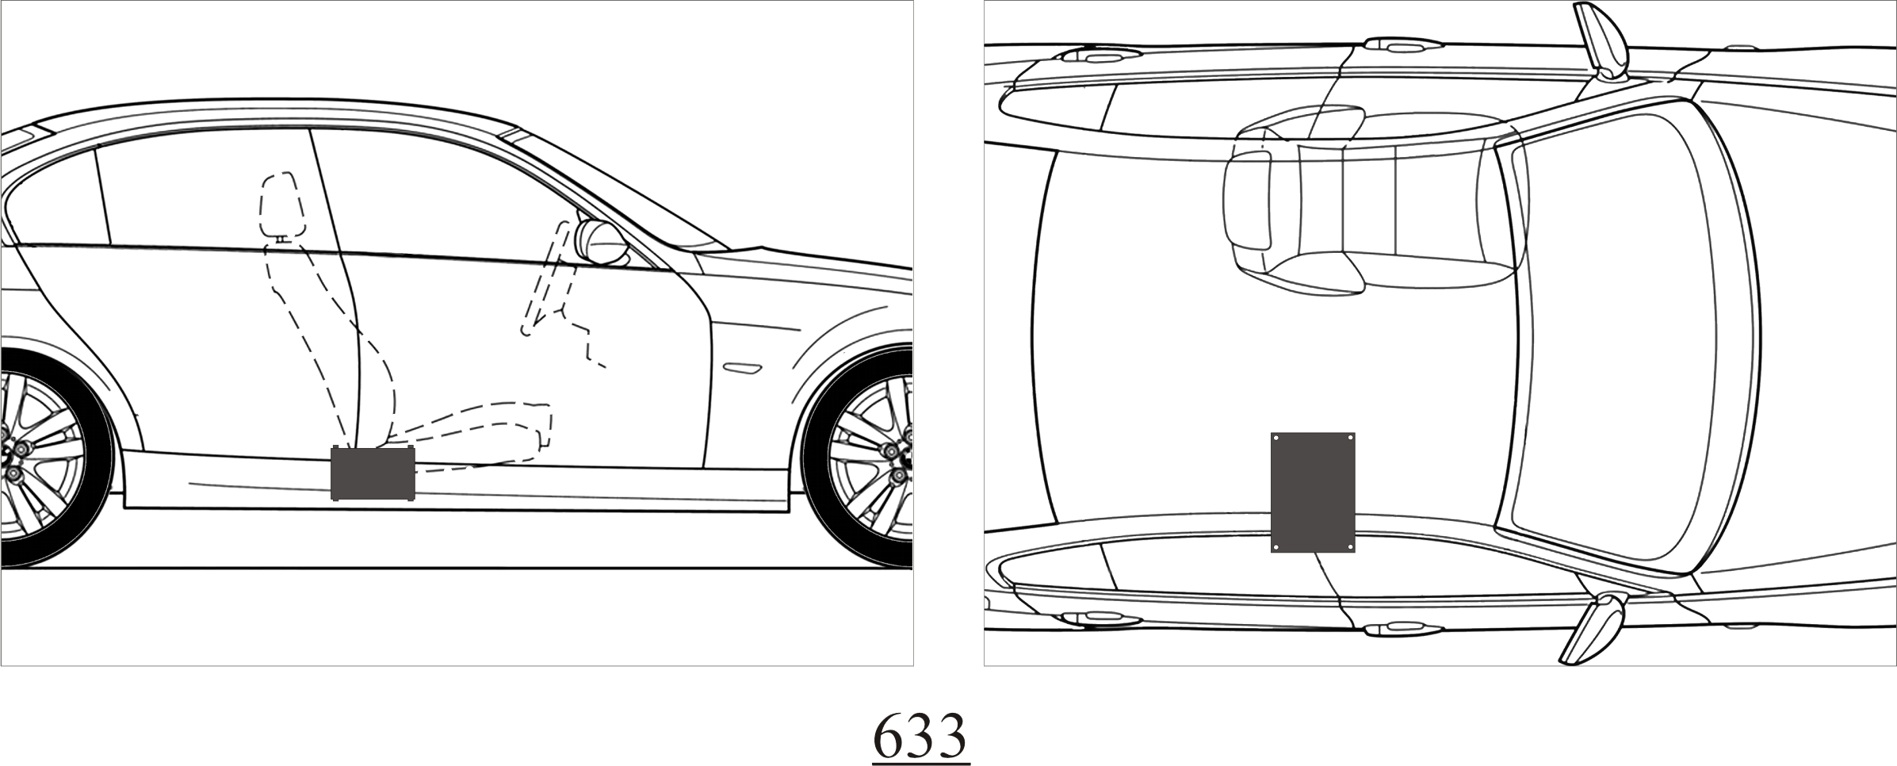
7 Engines
7.1. It is allowed to use only normally aspirated original engines having original fuel supply system. It is allowed to increase cubic capacity of engines, but within the repair limits, maximum being +1 mm of the standard. Total cubic capacity may not exceed 2% of the capacity for given class. Maximum compression rate: 10,5: l.
7.2. Fuel supply system – it is allowed to use only that fuel supply system which has been originally supplied together with the engine. Control unit - original.
Any adjustments of the fuel supply system are allowed. Control pressure device is not restricted. Air intake is not restricted till the casing of the throttles. It is allowed to use commercially available gasoline corresponding to DIN EN 228 (DIN 51 607).
7.3. Engine sump ventilation – it is allowed to disconnect it from the supply system, but in that case it shall be connected to a separate oil proof reservoir having minimum volume of 1 litre.
7.4. Air filter and its case – not restricted.
7.5. Throttle casing – original of the given model. Maximum - one. Maximum diameter - 60 mm.
7.6. Throttle control (including axis of the valve) – not restricted, but it shall be equipped with strong enough spring to close it in the case of damage to the control.
7.7. Fuel tank – original or accepted by FIA.
7.8. Fuel pumps – not restricted, but may not be placed in cockpit.
7.9. Fuel lines – if placed in cockpit, they shall be installed in accordance with Article 253 of Appendix J to the ISC.
7.10. Intake manifold – original. Machining allowed, but retaining outer parameters.
7.11. Exhaust manifold – original.
7.12. Exhaust piping – not restricted. The end of the pipe shall be within the perimeter of the bodywork of the vehicle.
The opening of the end of the exhaust pipe shall be not further inside than 100 mm from the side or rear dimension. The noise level shall be measured in accordance with the method approved by LAF, and it may not exceed 103 dB.
7.13. Engine block – original. Machining is allowed retaining outer parameters.
7.14. Cylinder head – original. Machining of the intake – exhaust ducts is allowed, valve guides are not restricted. Material of the valve seats – original.
7.15. Gasket of the cylinder head – original.
7.16. Crankshaft – original. Grinding of the necks is allowed within repair limits. Balancing is allowed provided it does not raise any suspicions concerning the weight-reduction.
7.17. Connecting rods – original Machining is allowed provided it does not raise any suspicions concerning the weight-reduction.
7.18. Pistons, piston rings and pins – not restricted.
7.19. Camshaft(s) – original. Driving gear of the camshaft – not restricted. In case of disputes the measurements shall be made in order to compare with the data of the manufacturer of the vehicle. The minimum diameter of the disk for the measurement of degrees shall be 200 mm.
7.20. Valves and driving parts thereof – valves shall be original. Maximum number of valves for engines up to 1600 ccm – four valves per cylinder; for engines up to 1800 ccm – three valves per cylinder; for engines up to 2000 ccm – two valves per cylinder. Machining of the valves to improve the form or surface is prohibited. Valve springs are not restricted. Rocker arms, axis of rocker arms as well as mounting elements and springs thereof shall be retained original. If the original system comprises hydraulic compensator, they may be rendered inactive mechanically. VANOS, VTEC and other valve overlap change systems is prohibited. If the original vehicle is equipped with such a system, it shall be removed, or pressure valves rendered inactive mechanically, and not by disconnection.
7.21. Oil pump – original. It is allowed to weld partitions in the engine sump. It is allowed to install oil deflectors in the engine sump.
7.22. It is allowed to install oil radiator.
7.23. Ignition system – original.
7.24. Cooling system – not restricted. It is not allowed to install additional radiators in the cockpit. The pump shall be original, the drive is not restricted.
7.25. Engine mountings – not restricted provided the placement of the engine and gearbox is retained original.
7.26. It shall be possible to seal the engine in places where the engine block connects with cylinder head and sump.
8 Clutch and gearbox, parts of power train
8.1. Flywheel – original. Machining is allowed.
8.2. Clutch disk – not restricted.
8.3. Clutch release – not restricted.
8.4. Gearbox – original, any modification of the given manufacturer of a vehicle. Maximum forward gears – five.
8.5. Wheel drive (axle shaft) – original.
8.6. Cardan drive - original.
8.7. Gear-change mechanism – not restricted.
8.8. Differential blocking - prohibited.
8.9 Differential casing - original. Final drive – free.
9 Suspensions
9.1. It is prohibited to change the number of shock absorbers.
9.2. Shock absorbers and struts – not restricted.
9.3. Springs – not restricted. Their type shall be retained.
9.4. Anti-roll bar – original.
9.5. Material of articulation joints of the suspension, silentblocks may differ from the original (i.e., harder silentblocks, aluminum, Uniball joints).
9.6. Front suspension and rear axle – original. Original suspension part may not be modified in any way, or its position changed except addition of material and making circular grooves for attachment of stop pads or fixing eccentrical bushing (adjustment screw, stud-bolts, bolts) in accordance with modifications allowed in point 9.5. It shall be possible, after removing the new part, to substitute it with the original one.
9.7. Bearing of the upper joint of a shock absorber – original.
9.8. Suspension travel limiter:
It is allowed to affix straps or cables to limit the suspension travel. For this purpose it is allowed to make holes of diameter not exceeding 8,5 mm in the suspension and bodywork.
10 Braking
10.1 All design shall be original. Any machining or treatment – forbidden except the following authorized modifications:
10.2. It is allowed to disconnect ABS and remove parts thereof which do not influence braking efficiency and do not impair driving safety. It is also allowed to disconnect and remove brake booster. Every case shall be decided by the Scrutineers of the event.
10.3. Brake lines – original or according to Article 253, point 3, of Appendix J to the ISC.
10.4. Parking brake is not compulsory, but recommended. Design of it – not restricted. In case the parking brake is retained the fixation mechanism to keep the lever in given position shall be removed.
10.5. Brake pressure regulator – not restricted.
10.6. It is allowed to machine brake disks in order to level the surface, and to improve characteristics of ventilation and self-clearing.
10.7. It is allowed to install other, also of a competition type, foot pedal system.
11 Steering
11.1. All parts of the steering system – original except the following authorized modifications:
11.2. Steering wheel – it is allowed to replace it, also with a competition type.
11.3. Anti-theft blocking device of the steering wheel shall be removed.
11.4. Steering booster – it is allowed to disconnect or remove it.
11.5. Steering shaft – original. It is allowed to install supporting brackets of free design between the bodywork and steering column in order to lower the steering wheel. Every case shall be decided by the Scrutineers of the event.
11.6. Rack-and-pinion – original.
12 Wheel and tires
12.1. Only tires accepted by the Regulations of the race for 2008 are allowed. The size of tires shall be 195/50/15. It is forbidden to change the pattern of the tread by any means.
12.2. Rims - maximum 7,0" (inches) wide. A flange between the rim and the wheel hub is allowed.
12.3. The wheel fixation by bolts may be changed for fixation by pins and nuts retaining their diameter.
12.4. Wheel together with a tire, when mounted on the vehicle, shall be covered by the bodywork when measuring vertically downward through the center of the wheel.
12.5. No part of the vehicle may touch the ground when any of the tires is flat except the rim of that wheel.
13 Electrical system
13.1. Design of the electrical system– not restricted provided that:
13.1.1. Alternator – original. May be removed.
13.1.2. A battery may be moved from the original location. In this case its fixation shall comply with Article 255, point 5.8.3., of Appendix J to the ISC.
13.1.3. All cables and wires shall be isolated and securely mounted.
13.1.4. The vehicle shall be equipped with the switch corresponding to Article 253, point 13, of Appendix J to the ISC. The switch shall be accessible by the pilot normally sitting in the seat, as well as from outside of the vehicle at the left or right pillar of the roof.
The location of the switch shall be marked on the outside of the vehicle with a blue triangle having sides of a minimum 80 mm.
13.1.5. The main electrical circuits (lighting, cockpit fan, radiator fan, fuel pump, windscreen wiper) shall be fitted with fuses, except the starter circuit.
14 Outlook of vehicles
14.1. The vehicle shall not have distinctive visual faults and defects (rust, deformed parts of the bodywork, cracked glazing in the field of direct vision etc.) which can impair safety of the event in any way, or create negative impression thereof.
14.2. Colouring of vehicles is not limited except requirements laid down by the Regulations.
14.3. Every vehicle shall have the Number of participant and mandatory superscriptions (advertising) as lay down by the Regulations of the event and provided for by the Organizers of the event.
14.4. Radiator grille shall be original.
14.5. It is not allowed to glue or cover with a tape the space between doors, bonnet, wings and elsewhere.
15 Final clauses
Technical Regulations can be amended for better understanding in cases of uncertainties, and these amendments shall be written and approved by the Circuit Race Committee of LAF two week prior to entering into force. It is obligation of the participant to prove compliance of the vehicle with the Regulations.
It is recommended to seek advice of the Organizers of the event in case of doubts.

